Re: Replacing the original Opioid Risk Tool (ORT) with the updated version
Action Requested
The Opioid Risk Tool (ORT), which was created by Dr. Lynn Webster in 2005 (Webster), was validated and updated in 2019 (Cheatle). The original version unfortunately contained a question about childhood sexual abuse, which only affected the risk scores of women. This created gender bias and led to misconceptions about this risk only affecting women. The result was that many women were denied appropriate pain care (Szalavitz).
The validation study shows that the question about preadolescent sexual abuse is irrelevant and an updated ORT was created. We formally request if you use the ORT in any capacity, whether it is worked into a risk score algorithm, listed on your website, or given at your facility, please make sure the original version is removed and replaced with the updated version.
Original Opioid Risk Tool (ORT)
The Opioid Risk Tool (ORT) was created in 2005. (Webster)
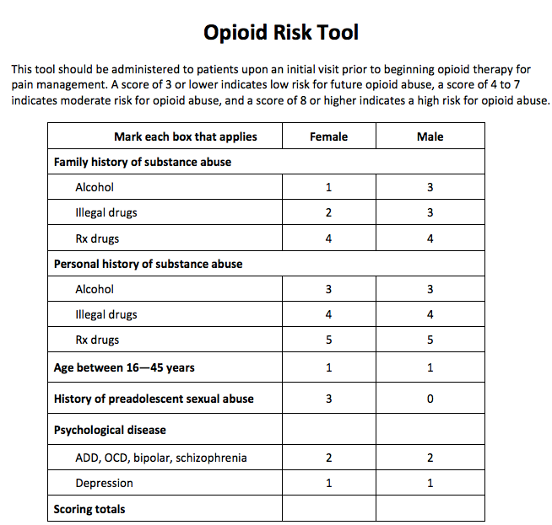
The question about sexual abuse was based on a study that was only about women, and therefore was only applied in this tool as a risk to women. (Szalavitz)
The ORT, using the sexual abuse question, has been used to deny women opioids for pain. Many women have shared this experience, which although the ORT only referred to preadolescent sexual abuse, doctors have also applied to any sexual assault. Some doctors have deemed it too risky to prescribe opioids to a woman who has been sexually abused of assaulted, and some have even claimed opioids are contraindicated in anyone who was sexually abused in childhood. Dr. Tim King, expert witness against a physician, stated:
And as I mentioned to you earlier, preadolescent sexual abuse is one of the biggest predictors of opiate misuse and addiction. She’s been put at extremely high risk because the real diagnosis is emotional pain due to mental illness and her inability to cope with – with problems related to her preadolescence and she has PTSD depression and anxiety. Those are pretty tell-tale for an unfortunate young woman for someone who suffered physical and emotional abuse as a young child. This should be recognized by any physician practicing pain medicine. It’s a major red flag. (Transcript of Jury Trial Exerpt Testimony Of Dr. Timothy King - Part 1 and 2, United States of America vs Charles R. Szyman)
Some of these women began sharing their stories on social media, and realized they weren’t alone in their experiences.
On September 21, 2019 Dr. Webster acknowledged this problem and warned against the MISUSE of the ORT:
It is a cruel misapplication of the ORT to use a background of sexual abuse as the only criterion to assess whether a patient should receive opioid therapy. The ORT is an important tool in mitigating harm that prescribing opioids could cause. It should not be weaponized to justify denying people in pain appropriate therapy. (Webster)
Despite Webster’s statement, stories continued to be told on social media about women being denied opioids due to sexual abuse or assault. One of these stories was discussed in an article in Wired. When denied IV opioids for kidney stones due to having been sexually abused as a child, the hospitalist told a patient:
Due to that I cannot give you any type of IV pain medication. You’ll thank me someday, because due to what you went through as a child, you have a much higher risk of becoming an addict, and I cannot participate in that. (Szalavitz)

New Study Validating the ORT
On January 25, 2019 Dr. Martin Cheatle studied and validated the ORT.
Some highlights of this study:
- The ORT was evaluated on pain patients with and without Opioid Use Disorder
- An ORT removing the preadolescent sexual abuse item had similar results
- An unweighted ORT without the sexual abuse item was superior
Based on the results of his study, Dr. Cheatle created an updated ORT removing the sexual abuse question. (Cheatle)

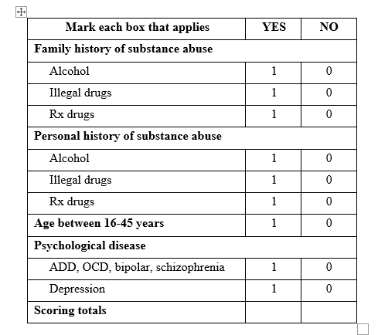

Unfortunately, there hasn’t been a formal effort to make sure the original ORT would be replaced by the updated version. This creates a problem because the ORT has been embedded in some Electronic Health Record platforms and also worked into some risk scores. It’s given by doctors and treatment centers. Since some risk scores such as NarxCare are proprietary, there is no way to know if the ORT is used in their algorithm, and if so which version:
Webster says he did not intend for his tool to be used to deny pain treatment—only to determine who should be watched more closely. As one of the first screeners available, however, it rapidly caught on with doctors and hospitals keen to stay on the right side of the opioid crisis. Today, it has been incorporated into multiple electronic health record systems, and it is often relied on by physicians anxious about over-prescription. (Szalavitz)
On June 29, 2022, Dr. Webster again made a statement acknowledging the misuse of the ORT. HE acknowledged the validation study done by Dr. Cheatle (Cheatle) and stated only the updated version of his ORT should be used:
It distresses me to know that, while the original ORT served to help assess the risk opioids posed for individuals, it has also caused harm. Since the question about a woman's sexual abuse history does not provide any additional benefit, there is no reason to retain it. The revised ORT should be used instead of the original ORT. (Webster)
We have noticed that most government agencies and individual doctor and treatment centers still use the original version of the ORT.
Taking into account the facts in this letter, if you use the ORT in any capacity, whether it is worked into a risk score algorithm, listed on your website, or given at your facility, please make sure the original version is removed and replaced with the updated version.

Signed,
Claudia Merandi, Founder and CEO of The Doctor Patient Forum
Bev Schechtman, VP of The Doctor Patient Forum
Carrie Judy, Researcher at The Doctor Patient Forum
Chad D. Kollas, MD, FACP, FAAHPM; Orlando, Florida

References
Cheatle, Dr. Martin. "Development of the Revised Opioid Risk Tool to Predict Opioid Use Disorder in Patients with Chronic Non-Malignant Pain." The Journal of Pain (2019): 842-851.
Szalavitz, Maia. "The Pain Was Unbearabley So Why Did Doctors Turn Her Away?" Wired 11 August 2021. Article.
Transcript of Jury Trial Exerpt Testimony Of Dr. Timothy King - Part 1 and 2, United States of America vs Charles R. Szyman. No. CR 16-00095-WCG-1 . United States District Court For The Easterd District Of Wisconsin . 15 November 2017. Court Transcript.
Webster, Dr. Lynn. "Another Look at the Opioid Risk Tool." Pain News Netword 29 June 2022. Article.
—. Predicting behaviors in opioid-treated patients: preliminary validation of the Opioid Risk Tool. Pain Medicine, 2005.
—. "Prediction Aberrant Behaviour in Opioid-treated Patients: Preliminary Validation of the Opioid Risk Tool." Pain Medicine (2005): 432-442.
—. "The Opioid Risk Tool Has Been Weaponized Against Pain Patients." Pain News Network (2019). Article.

